INTRODUCTION

Monster Energy, the company’s flagship product, is positioned as a high-energy drink for a young, active demographic. The brand image is built around extreme sports, music, and gaming, resonating with its target audience. This strong brand positioning helped Monster to establish a loyal customer base and also differentiate itself in a competitive market. Founded in 2002 by Andrew Pessin in California, Monster Beverage Corporation achieved success and today ranks as the second biggest energy drink in the globe after Red Bull. Monster energy is known to have crude branding, a unique design on the can which is black and green, and has attached itself firmly to youth clubs and extreme sports. Currently, Monster is available in over 140 different countries around the world, and it is poised to broaden its macro market share by pursuing several aggressive sponsorships, new marketing, and an even expanded distribution.

While much of Monster’s success is attributed to its promotional strategies and brand positioning, the company’s ability to transport, store, and package its products effectively is equally critical. Energy drinks are high-volume, fast-moving consumer goods (FMCG), and their global availability depends on efficient logistics and supply chain management. Monster’s partnership with The Coca-Cola Company since 2015 has further strengthened its global reach by leveraging Coca-Cola’s established distribution channels.

Transportation, storage, and packaging are not merely operational necessities for Monster; they are strategic tools that contribute directly to brand identity, cost efficiency, and customer experience. Monster’s core product — high-caffeine, high-sugar beverages — has attracted increasing scrutiny due to health concerns. Regular consumption carries potential risks such as heart strain, sleep disruption, and dependency, raising regulatory and consumer pressure on the brand to adapt.

This report focuses on analyzing Monster Energy’s practices in transportation, storage, and packaging, exploring how these elements support the company’s overall marketing and growth strategy. It also identifies challenges and opportunities, particularly in the areas of sustainability, cost optimization, and technological innovation, which will shape Monster’s competitive advantage in the years ahead.

INDUSTRY PROFILE
The Energy Drinks Market size is estimated at 78.02 billion USD in 2025, and is expected to reach 104 billion USD by 2030, growing at a CAGR of 5.91% during the forecast period (2025-2030).
The energy drinks industry is experiencing a significant transformation driven by evolving consumer lifestyles and preferences, particularly in the sports and gaming sectors. The United States has emerged as the global leader in esports, with over 3.7 thousand active competition players, while outdoor activities continue to gain momentum. Notably, hiking has become the most popular outdoor activity in the United States, with approximately 60 million participants in 2022. This dual trend of digital and physical activities has created diverse consumption occasions for the energy drinks market, leading manufacturers to develop specialized products catering to both segments.
The energy drinks industry is a fast-growing segment within the global non-alcoholic beverage market. Originally targeted at athletes and extreme sports enthusiasts, energy drinks have now gained mainstream popularity among young adults, students, and working professionals seeking quick energy boosts, enhanced focus, and lifestyle appeal. The industry includes products that typically contain high levels of caffeine, sugar, taurine, B-vitamins, and other stimulants.
The market is highly competitive and concentrated, dominated by a few key players:
- Red Bull GmbH holds the largest share, known for its premium pricing and consistent brand image.
- Monster Beverage Corporation is the second largest, competing on variety, volume, and aggressive marketing.
- Rockstar Energy (PepsiCo) and NOS (Coca-Cola) are other major players.
- Numerous regional and niche brands (Bang Energy, Reign) are introducing healthier, plant-based alternatives, reflecting a shift toward wellness-focused products.
Product innovation and strategic partnerships have become crucial differentiators in the energy drink sector. In 2023, several major brands launched groundbreaking products and formed key alliances to enhance their market presence. For instance, PepsiCo introduced Rockstar Energy + Hemp, incorporating hemp seed extract alongside traditional energy drink ingredients, while GÖNRGY collaborated with German social media star MontanaBlack to launch a new range of canned energy drinks. Celebrity partnerships have also gained prominence, as evidenced by Prime's collaboration with YouTube stars KSI and Logan Paul, and Celsius's alliance with Olympic gold medalist Shaun White.
Trends shaping the industry include:
- Health consciousness → Consumers are demanding lower sugar, natural ingredients, and transparency in labeling.
- Sustainability → Pressure to reduce environmental impact through eco-friendly packaging and ethical sourcing.
- Digital marketing → Heavy reliance on social media, influencers, esports sponsorships, and experiential campaigns.
- Regulatory scrutiny → Governments are imposing stricter guidelines on caffeine content, age restrictions, and advertising claims due to potential health risks.

While the industry offers strong growth potential, brands must navigate the dual challenge of meeting energy demands while addressing health and environmental concerns. Monster Energy operates in this dynamic landscape, balancing aggressive branding with the need for product innovation and responsible marketing to remain competitive and capture future market leadership.

Problem Statement: Health Risks and Consumer Perception

Monster Energy has built its brand on delivering powerful stimulation through a formula combining caffeine, taurine, sugar, and various functional additives like inositol and L-carnitine. While this blend is effective in producing an immediate energy boost, it also raises significant health concerns that limit the drink’s long-term consumer acceptance and brand positioning.

- Caffeine: A 16 fl oz can of Monster contains ~160–180 mg of caffeine. While this is within the FDA’s daily limit (400 mg), it represents nearly half the allowance in a single serving. For sensitive users or multiple-can consumers, risks include insomnia, anxiety, heart palpitations, and chest pain.

- Taurine: Promoted for endurance and alertness, taurine amplifies the stimulating effect when paired with caffeine. In excess, this combination stresses the cardiovascular system, making Monster unsuitable for daily use.

- Sugar: With ~54 g per can, Monster exceeds double the WHO’s recommended daily sugar intake, contributing to obesity, diabetes, and energy crashes — problems increasingly criticized by health-conscious consumers.

- Inositol: Marketed as a “mood and cognition” enhancer, inositol is included in amounts too low to be clinically impactful. Its role is primarily perceptual, creating a wellness halo without real physiological benefit.

- L-Carnitine: Linked to fat metabolism and performance in marketing, but again under-dosed compared to effective supplementation levels. Its benefits in Monster are negligible, making it more of a branding ingredient than a functional one.

PERSONAL EXPERIENCE
Gym & Fitness use: I started drinking Monster as a pre-workout substitute, and it quickly became part of my fitness routine. The instant rush of energy made workouts feel more intense and productive. But without realizing it, my intake rose from occasional use to 2–3 cans a day. Even though I was drinking the sugar-free version, the artificial sweeteners were equally addictive, making it difficult to cut back. Soon, I began feeling heaviness in my chest and discomfort around my heart — clear warning signs that my consumption was excessive. I started to drink it outside the gym:

Habitual Purchasing: The drink also crept into my everyday life. Whenever I visited a grocery store, I found myself automatically grabbing a Monster, even when I didn’t plan to. What started as a choice became a compulsive habit, where Monster was always in my shopping basket.

Travel Consumption: On longer trips, especially those lasting 4–5 hours, I began carrying not just a few cans, but entire crates of Monster with me. This was when I realized how much the drink had shifted from being an occasional boost to an essential item I couldn’t do without.

Studying & All-Nighters: Beyond fitness and travel, Monster also became my go-to for academics. Whenever I needed to study late into the night or pull an all-nighter, I would sit with a can at my side. It kept me awake, alert, and energized, making it feel like the perfect tool for both a study geek and a gym rat alike.
Why I Want to Solve This Problem
Despite the health concerns and personal challenges I’ve faced with Monster Energy, I remain one of its biggest consumers and supporters. The reason is simple: Monster has qualities that few other drinks can match.

- Taste & Variety: From the classic blends to unique flavors, Monster consistently delivers one of the best taste experiences in the energy drink market. The variety ensures there’s a flavor for every mood and occasion.
- Sugar-Free Options: The availability of sugar-free versions, like my personal favorite (the White Monster) shows that the brand is already aware of shifting consumer demands and has made efforts to adapt.
- Performance Benefits: Whether it’s as a pre-workout enhancer, a companion for late-night study sessions, or a pick-me-up on long trips, Monster provides the energy and stimulation I need to perform at my best.
- Lifestyle Connection: Monster isn’t just a drink it’s part of a culture, whether in sports, fitness, gaming, or daily life. For fans like me, it has become more than just an energy boost; it’s an identity marker.

Because of these strengths, I don’t want to stop consuming Monster. Instead, my motivation is to see it evolve into a healthier version of itself — one that delivers the same taste, energy, and lifestyle value, but without the negative health consequences. If Monster can reformulate or expand its product line to make regular consumption safe, it has the potential to not only keep loyal consumers like me but also dominate the energy drink market by being the best and healthiest option available.

SOLVING THE PROBLEM
Monster Energy’s challenge lies in balancing its strengths (taste, variety, performance benefits) with the health concerns raised by excessive caffeine, taurine, sugar, and addictive additives. As a loyal consumer myself, I don’t want to stop drinking Monster; rather, I want to see it evolve into a healthier version that supports long-term consumption without negative effects. To achieve this, we can apply several strategic frameworks and theories.

1. SWOT Analysis – Understanding the Current Position
- Strengths: Strong global brand, loyal fanbase, wide flavor portfolio, sugar-free variants, strong lifestyle association (sports, gaming, fitness).
- Weaknesses: High reliance on caffeine and taurine, addictive consumption patterns, negative health perception, lack of truly healthy alternatives.
- Opportunities: Rising demand for wellness-oriented functional beverages, innovation in natural sweeteners/adaptogens, expansion into fitness-preworkout markets.
- Threats: Competition from Celsius, Prime, and other “clean energy” brands; growing regulation on sugar/caffeine; shifting consumer preferences toward health.

Solution via SWOT: Monster should leverage its strengths (brand, flavors, lifestyle) to create new products that address weaknesses (health risks). By innovating healthier alternatives, Monster can tap into opportunities (wellness market) and defend against threats (competition & regulation).

Problem–Solution: Building a Healthier Monster
Monster Energy’s biggest strength is its versatility it is consumed by gym-goers, students, travelers, gamers, and everyday users. However, the current “one-size-fits-all” formula comes with health risks due to excess caffeine, taurine, sugar, and addictive additives. The solution is not to replace Monster entirely, but to expand the product portfolio with health-oriented versions designed for specific purposes.

1. Purpose-Based Product Versions

- Monster Sport (Pre-Workout Formula)
  - Target: Gym-goers and athletes.
  - Features: Moderate caffeine, electrolytes, BCAAs, natural energy boosters (ginseng, green tea extract).
  - Benefit: Provides safe pre-workout stimulation without cardiovascular strain.

- Monster Focus (Study & Work Formula)
  - Target: Students and professionals pulling long study/work sessions.
  - Features: Lower caffeine, nootropics (L-theanine, ginkgo biloba), vitamins for brain health.
  - Benefit: Enhances concentration and alertness without jitters or addiction.

- Monster Daily (Lifestyle/Everyday Use)
- Target: General consumers who want a daily refreshment.
- Features: Very low caffeine, natural sweeteners (stevia, monk fruit), fruit-based flavors, added hydration elements.
- Benefit: Safe for frequent consumption; positions Monster as a healthier alternative to soda.

Monster Zero Impact (Wellness & Recovery)
- Target: Travelers, casual users, and health-conscious drinkers.
- Features: Zero artificial sweeteners, adaptogens (ashwagandha, rhodiola), hydration support (coconut water, electrolytes).
- Benefit: Supports energy + recovery without overstimulation or long-term harm.
2. Health Precautions & Transparency
- Clear Labeling: Display caffeine, taurine, and sugar content prominently, with daily safe limits for consumer awareness.
- Portion Control: Introduce smaller can sizes (e.g., 8 oz functional versions) to reduce unintentional overconsumption.
- Responsible Marketing: Shift from only extreme-sports branding to health + performance branding, appealing to fitness and wellness segments.

3. Ingredient Reformulation
- Replace artificial sweeteners with natural alternatives (stevia, monk fruit) to reduce addictive tendencies.
- Use natural caffeine sources (green coffee bean, yerba mate, matcha) for smoother energy release.
- Reduce taurine reliance and replace with functional amino acids or nootropics.
- Add heart-friendly ingredients (magnesium, electrolytes) to offset cardiovascular strain.

Solution Summary
Instead of being a single high-caffeine, sugar-heavy energy drink, Monster should evolve into a portfolio of purpose-driven, health-conscious products. This ensures that:
- Consumers like me can continue enjoying Monster daily without health risks.
- Monster stays relevant against competitors like Celsius and Prime.
- The brand becomes the leader in both performance and wellness energy drinks.

Ansoff’s Matrix: Growth Strategy for Monster Energy
Monster’s path forward lies in evolving beyond its current “one-size-fits-all” formula. By leveraging the Ansoff Matrix, Monster can pursue growth through both product innovation and market expansion while solving its health concerns.

1. Market Penetration (Existing Products + Existing Markets)
- Focus: Encourage healthier consumption of current products among existing consumers.

- Strategies:
- Stronger promotion of existing sugar-free lines (e.g., White Monster).
- Campaigns around responsible consumption (“Know Your Limits” initiatives).
- Limited-time smaller can sizes (portion-controlled servings) for daily use.

2. Product Development (New Products + Existing Markets)
- Focus: Develop new, health-conscious Monster versions for loyal consumers (gym-goers, students, travelers).

- Strategies:
- Monster Sport → pre-workout formula with safe caffeine + BCAAs.
- Monster Focus → study/work version with nootropics + vitamins.
- Monster Daily → everyday low-caffeine lifestyle option with natural sweeteners.
- Monster Zero Impact → wellness & recovery line with adaptogens + electrolytes.
- Impact: Keeps loyal consumers engaged while addressing health concerns.

3. Market Development (Existing Products + New Markets)
- Focus: Take current Monster products into new geographies and untapped segments.

- Strategies:
- Expansion into developing markets (Asia, Africa) where energy drink growth is high.

- Target female consumers (often underserved in extreme-sports marketing) with lighter, wellness-focused branding.
- Position existing sugar-free lines as healthier soda alternatives in markets shifting away from soft drinks.

4. Diversification (New Products + New Markets)
- Focus: Move beyond energy drinks into functional wellness beverages.

- Strategies:
- Launch Monster Hydrate → competing with Gatorade/BodyArmor in sports hydration.
- Introduce Monster Mind → nootropic sparkling water for focus + mood.
- Create Monster Recovery → post-workout recovery drink with protein + electrolytes.

- Impact: Positions Monster as not just an energy brand, but a comprehensive functional beverage leader.

Strategic Insight
Using Ansoff’s Matrix, Monster can pursue growth on all four fronts:

- Deepen loyalty through responsible consumption (penetration).
- Innovate healthier versions for its current fans (product development).
- Expand into new demographics/regions (market development).
- Evolve into a functional wellness brand, not just an energy drink company 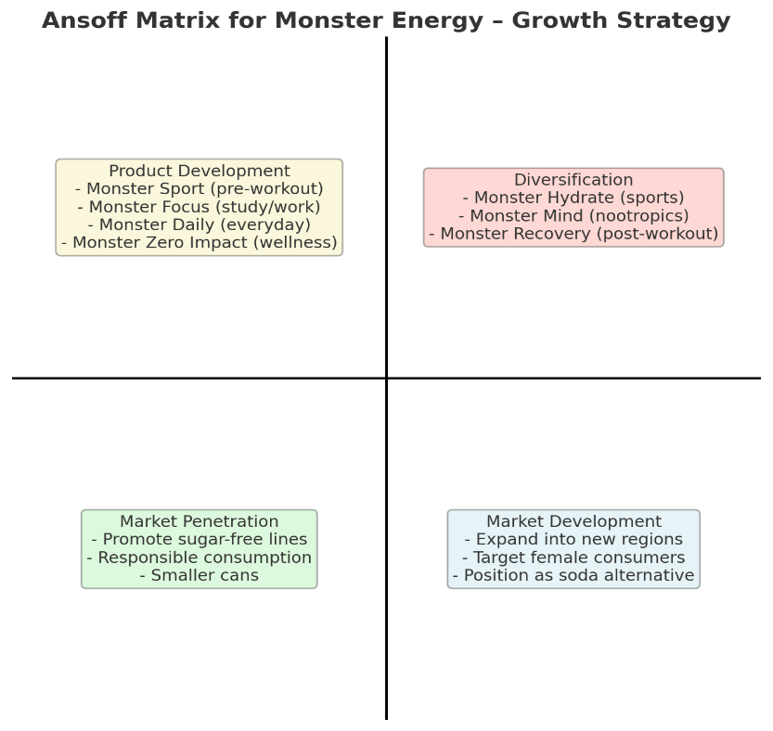

This strategy ensures Monster not only retains loyal heavy users like myself but also wins over new, health-conscious consumers securing its future in an increasingly wellness-driven market.

🔹 Competitive Benchmarking (Updated with Key Insights)

- Monster Energy (Ultra Zero / White Monster)
- The White Monster (Monster Ultra Zero) has achieved cult-like status in the global fitness community.
- Gym influencers frequently endorse it as one of the best pre-workout energy drinks due to its taste, zero sugar appeal, and “cleaner” feel compared to traditional Monsters.
- However, overconsumption remains a critical issue: despite being sugar-free, the high caffeine and artificial sweeteners still pose health risks.

- Celsius
- Positioned as a “clean energy” drink with natural ingredients, no artificial sweeteners, and metabolism-boosting claims.
- Strongly associated with the fitness and wellness lifestyle, attracting younger and health-conscious consumers.
- Its rapid growth was fueled by PepsiCo distribution and strategic influencer partnerships.

- ZOA Energy (Dwayne “The Rock” Johnson’s brand)
- Leverages a celebrity wellness image and emphasizes natural caffeine from green tea & unroasted coffee beans.
- Positioned as a healthier daily energy option bridging sports nutrition and mainstream energy drinks.

- PRIME Energy
- Founded by KSI and Logan Paul, PRIME became a cultural phenomenon through massive influencer marketing and direct-to-fan engagement.
- Despite health controversies (e.g., high caffeine levels, regulatory scrutiny), the brand’s pop-culture appeal skyrocketed sales globally.

🔹 Key Strategic Insight

Monster already has the brand equity, cult following, and taste advantage (especially with White Monster in the gym community).
But competitors like Celsius and ZOA are proving that health-first positioning is what drives sustainable growth today, while Prime demonstrates the power of influencer-led hype.
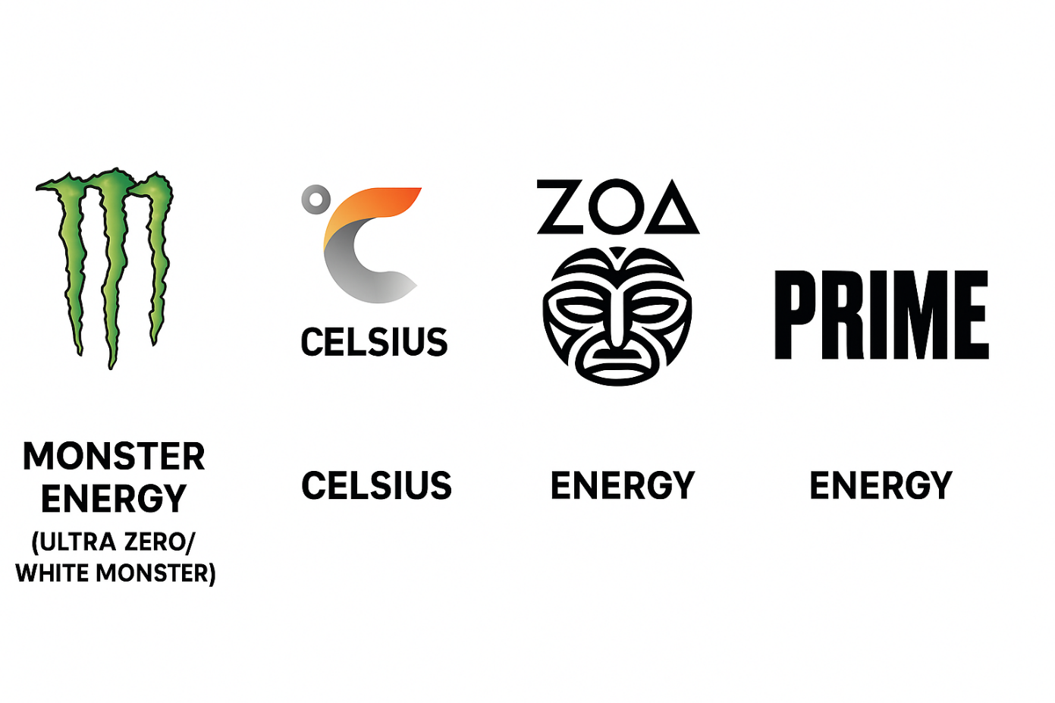

🔹 Conclusion

Monster Energy has been more than just a drink for me it became part of my gym routine, late-night study sessions, and even long travels. The White Monster in particular was my go-to, and for a while, it felt perfect: sugar-free, great taste, and an instant energy rush. But over time, I found myself drinking 2–3 cans a day without even realizing it. Whether at the grocery store, on a road trip, or cramming for an all-nighter, Monster slowly became less of a choice and more of a habit.

This personal experience made me realize the core problem: Monster is amazing in the moment, but its addictive nature, high caffeine levels, and artificial ingredients create real risks when consumed daily. And I know I’m not alone especially in the fitness community, where White Monster has achieved cult status as a pre-workout drink, many people end up overconsuming it.

At the same time, when I look at the competition, I see a clear pattern: Celsius and ZOA are winning because they highlight health and clean energy, while Prime has exploded by connecting to pop culture and influencers. Monster already has the loyal fanbase, global reach, and taste advantage, but it risks falling behind if it doesn’t adapt to these new consumer expectations.

That’s why I believe the solution isn’t to stop drinking Monster it’s to make it better. By creating purpose-driven versions (Monster Sport, Monster Focus, Monster Daily) with health-conscious ingredients and clear guidelines, Monster can still give the energy and thrill people love, but without the harmful effects.

In short: Monster doesn’t need to change who it is it just needs to evolve into a safer, healthier version of itself. That way, consumers like me can keep enjoying it daily, without worrying about long-term damage. Monster can remain the ultimate energy drink not just for hype, but for health and performance too.

